**The Integration of Computer Vision for Dynamic Pricing of Self-Service Printing Kiosk in Colegio de Montalban**

This proposal is presented by:

**Tuyor, Rachel A.**

**Evidor, Jerusalyn A.**

**Fajardo, Christian Gil R.**

**Guevarra, Richard DG.**

BS in Computer Engineering

On

February 2026

**--------------------------------------------------------------------------**

**RESULT:**



|  |  |
| --- | --- |
| **Approved** | **Disapproved** |

**Remarks:**

*Note: One (1) title page per project proposal.*

**Form for PROJECT PROPOSAL**

**Title:**

**The Integration of Computer Vision for Dynamic Pricing of Self-Service Printing Kiosk in Colegio de Montalban**

## Research Agenda Covered:

* Overview of the Proposal
* Related Studies
* Statement of the problem
* Proposal Objectives
* Scope of the project
* Initial Design
* Estimated Costs
* Benefits of the Project

## Overview of the Proposal:

Self-service technology offers a proven and widely accepted model for providing convenient, on-demand services in environments where fully staffed models face operational limitations. This principle is evident in the evolution of vending machines into versatile tools, and more recently in the widespread adoption of interactive kiosks by global service providers. Internationally, this model is a standard in countries like Japan, where convenience store chains utilize multi-function kiosks as a more accessible alternative to traditional staffed centers (Lane, 2014). Informational guides on these markets show that modern kiosks provide reliable printing and scanning through wireless uploads and digital integration (Dang, 2024). Documented industry practices for these systems often utilize a standardized pricing structure based on paper size and color selection. According to Dang (2024), established systems in Japan typically maintain a set fee, such as 10 yen for black and white documents, regardless of the specific ink density on the page. While this model offers simplicity for the user, it means that a document with a single line of text and one with a dense graphic are charged the same amount. This common industry practice creates a fundamental issue of fairness, because the price charged to a user does not reflect the actual resources, such as ink, that their specific document consumes.

This project is being undertaken in direct partnership with the CDM Business Hub at Colegio de Montalban, the official campus enterprise responsible for student services. The Hub’s CEO serves as the primary stakeholder, providing first-hand insights into the day-to-day operational challenges and student needs on campus. This collaboration is crucial because it grounds the project in a specific, documented community problem. It also ensures that the developed solution has a clear path for sustainable implementation and long-term support within the institution, positioning the project as a practical, student-led innovation designed to deliver real value to its community partner.

The initial stakeholder interview confirmed several specific problems facing the student community that this project is designed to solve. The first was a lack of accessibility to basic printing services, a situation that previously forced students to go off-campus for their needs. The CEO confirmed there is a high unmet demand, stating "lahat ng mga student dito, lumalabas pa talaga" (all of the students here still have to go outside), and added that students frequently inquire about on-campus services only to find none exist. The second problem is the low viability of a traditional, staffed print shop, she highlighted the difficulty of maintaining consistent service solely with a student workforce, stating that availability is often interrupted "kasi may klase" (because they have classes) and that schedules are therefore "hindi rin consistent" (not consistent). The CEO considered such a solution to be fundamentally unreliable due to the logistical challenges of scheduling student attendants around their own conflicting class schedules. This operational barrier led her to directly endorse an automated model as the only practical and reliable solution for the campus.

While local research has documented the development of automated printing kiosks in the Philippines, exploring innovations in hardware and user interaction, a significant research gap exists in their underlying economic model. These studies consistently rely on traditional, pre-set flat-rate pricing and do not address the issue of fairness for the end-user. Documented information on established global systems confirms that multi-function kiosks, which include printing, copying, and scanning, are the recognized industry standard for on-demand services (Strusiewicz, 2024). However, the fixed-price model remains a global standard for automated printing. Since this approach is widely used in both local prototypes and international commercial machines, there is an opportunity to investigate resource-based pricing as a potential enhancement. The application of Computer Vision (CV) to create a dynamic, usage-based pricing engine for a self-service kiosk is a technical solution that has been largely overlooked in the existing literature. This project is designed to fill that specific gap by developing and documenting the implementation of such a system. In doing so, the project must also navigate a known challenge associated with this advanced technology, which is the issue of user trust in algorithmic systems that can be perceived as an untrustworthy 'black box.'"

To address these interconnected challenges, our project will deliver a comprehensive, self-service printing kiosk. The system’s core innovation is a computer vision (CV) engine that analyzes a document's pixel coverage to calculate a fair, usage-based price, directly tying the cost to resource consumption. This engine is integrated into a fully automated kiosk that features an intuitive touchscreen interface, file uploads via both USB and a local Wi-Fi network, and a paper dispensing mechanism for various sizes. The payment system will accept coins and bills. To solve the problem of an unattended machine running out of change, it will issue scannable QR code receipts for any unclaimed credit. Users can scan this receipt later to redeem their change or use the credit as payment for their next printing job. To manage the technical risks of integrating this custom hardware and software, development will be guided by an Agile methodology, which allows for building and testing in iterative cycles. The project will conclude with a formal validation of the finished kiosk, confirming that the design choices made successfully address the core challenges of accessibility, fairness, and user trust.

## Related Studies:

|  |  |
| --- | --- |
| **RRL Author and Title** | **Contribution to our Research** |
| **Self-Service Technology for Convenience and Accessibility** | |
| Bodhale, J., & Kulkarni, J. S. (2017). Case Study on Different Vending Machines | This study provides a foundational validation for the project's core premise by establishing the Vending Machine (VM) as a successful model for on-demand, staff-free service delivery. It supports the argument that an automated kiosk is a viable solution for providing services in locations where dedicated staff are impractical. |
| Wani, M., & Saha, S. (2024). Role of vending machines in providing public facilities. ResearchGate. | This research demonstrates that the application of self-service technology has evolved beyond simple product dispensing into "versatile solutions that enhance public accessibility." This supports the project's goal of applying the SST model to a more complex service like multi-function printing. |
| Lee, D. H. (2022) - Consumers' experiences, opinions, attitudes, satisfaction, dissatisfaction, and complaining behavior with vending machines. | This study identifies a key operational benefit of self-service systems, which is the ability to improve operations and balance the workload of human staff. This contribution is important to our research as it provides an academic foundation for using an unattended model to support manned service counters. It directly aligns with the stakeholder's observation regarding the scheduling constraints of student assistants who cannot provide constant service due to their classes. By showing the advantages of automated models, this study helps frame the kiosk as a practical solution to the logistical realities of managing a student workforce. |
| Mansor, M., et al. (2018). Vending machine purchasing experience among students in the university’s residential college. | This study is critical as it confirms the high acceptance of automated services within the project's target environment: a university campus. It provides direct evidence that students, the target demographic, view automated services as a highly acceptable alternative when primary options are unavailable, justifying the kiosk's role in filling service gaps. |
| **Automated Printing Services in the Philippine Context** | |
| Perucho, R. C. A., & Diamante, R. A. (2024). Development of an Internet of Things based printer vending machine. International Journal of Engineering Research in Computer Science and Engineering. | This study serves as a direct local precedent, confirming the relevance and timeliness of developing automated printing kiosks for the Philippine academic market. Crucially, its reliance on a traditional pricing model helps to define this project's core innovation and research gap. |
| Falcon, G. C., et al. (2024). Optimizing user interaction and notification efficiency in smart coin-operated printing kiosk with real-time SMS notifications and interactive features. International Journal of Latest Technology in Engineering, Management & Applied Science | This local research demonstrates an existing effort to improve the user experience of printing kiosks in the Philippines. However, its focus on hardware and notifications, while neglecting pricing fairness, sharpens this project's contribution by showing we are addressing a key aspect of UX that has so far been overlooked. |
| **Enhancing Systems with Applied Computer Vision** | |
| Jain, A., et al. (2024). A computer vision-based model to implement automation in retail checkouts using YOLOv5. SSRN. | This study establishes a strong precedent for using computer vision to add intelligence to a transactional process. It provides a conceptual parallel: just as their CV model replaces manual barcode scanning, our CV model replaces a manual flat-rate price, validating the application of CV in this context. |
| Gangal, A., et al. (2021). Complete scanning application using OpenCV. | This paper provides the direct technical blueprint for the project's core software engine. It details a complete and accepted methodology using Python and OpenCV for analyzing a document's visual properties (e.g., via grayscale conversion and thresholding), thereby validating our specific choice of software stack and analytical approach. |
| Buckler, M., et al. (2017). Reconfiguring the imaging pipeline for computer vision. Proceedings of the IEEE International Conference on Computer Vision (ICCV). | This paper explains that computers don’t need a “pretty” picture to understand a document’s contents. It shows that we can strip away unnecessary visual enhancements to make the pricing engine faster and more efficient without losing accuracy in our pixel-coverage calculations. |
| **Principles and Ethics of Algorithmic Dynamic Pricing** | |
| Basal, M., et al. (2024). Dynamic pricing strategies using artificial intelligence algorithm. Open Journal of Applied Sciences. | This study is central to framing the project's primary human-centric challenge. It provides the academic terminology of "dynamic pricing" and formally introduces the "black box" problem, warning that non-transparent algorithms can erode user trust. This directly justifies our fourth research question and objective. |
| Seele, P., et al. (2019). Mapping the ethicality of algorithmic pricing: A review of dynamic and personalized pricing. Journal of Business Ethics. | This review adds academic weight and an ethical dimension to our focus on transparent design. It argues that a lack of transparency can be perceived as manipulative, framing our user trust challenge not just as a UX issue, but as a critical ethical consideration that a well-designed system must address. |
| **The Critical Role of User Experience (UX) and Interface Design** | |
| Xavier, K., et al. (2023). Customer satisfaction from the self-service kiosks’ UI/UX and the customer continuance intention to use. | This research provides the theoretical link between interface design and project success. It identifies "perceived usefulness" and "ease of use" as primary drivers of user satisfaction, directly justifying this project's significant focus on developing a user-centric interface (Objective #1). |
| De Jesus, S., et al. (2024). User interface (UI) on self-service kiosks’ machine in fast-food industry in Nueva Ecija, Philippines: Its’ correlation towards customers’ experiences. | This study provides powerful evidence for the project's viability within a local Philippine context. It confirms that the success of SST in the region is heavily influenced by a positive user experience, validating the project's mixed-methods approach that emphasizes both technical function and user satisfaction. |
| Lee, Y.-S., et al. (2025). Design of interactive systems: Information visualization methods of self-service technology in fast food restaurants. Computers in Human Behavior Reports. | This study provides a clear warning about the consequences of neglecting user-centric design. It argues that even technically superior automation can fail if the user experience is poor, justifying why a significant portion of this project's validation is dedicated to UX metrics and not just technical performance. |

## 

## Statement of the Problem:

On-campus printing at Colegio de Montalban is a vital necessity for the timely submission of academic requirements, as off-campus services are inconvenient and staffing a student-run shop is impractical due to scheduling challenges. An automated kiosk solves the staffing problem, but its typical flat-rate pricing creates a new issue of fairness by not accounting for the actual content printed.

While existing local studies, such as the work of Perucho et al. (2024), have made significant progress in developing automated printing kiosks, many current models utilize a traditional flat-rate pricing system. This established model typically charges a fixed amount, such as 5 pesos per page, regardless of the document's actual ink coverage. This presents an opportunity to explore a dynamic pricing system that calculates costs based on actual resource consumption, which could offer a more tailored pricing experience for students. However, transitioning to an automated pricing model introduces a research challenge regarding user trust, as students may be unfamiliar with how these costs are calculated. Therefore, this research focuses on ensuring the system is not only accurate and reliable, but also transparent enough to earn student confidence.

This research aims to address the following questions:

1. How can a self-service kiosk be designed to effectively solve the problem of limited on-campus printing access, with its usability validated against the Interaction Capability criteria of ISO/IEC 25010?
2. What system design is required to enable an unattended kiosk to operate continuously without a human attendant, ensuring it meets the Reliability standards of ISO/IEC 25010?
3. How can a computer vision algorithm be developed to accurately classify document ink coverage for a multi-tier pricing model, satisfying the Functional Suitability requirements of ISO/IEC 25010?
4. What interface design strategies are necessary to make the pricing process transparent and build student trust, validated against the Interaction Capability characteristic of ISO/IEC 25010?

## Proposal Objectives:

The general objective of this research is to design, develop, and evaluate a “Printing Kiosk with Dynamic Pricing using Computer Vision” to provide a fully automated, on-demand printing solution for the students of Colegio de Montalban. This self-service kiosk will handle printing, copying, and scanning, and dispense various paper sizes for manual loading. A central feature is the integration of a pixel coverage analysis engine that uses computer vision (CV) to calculate and apply a usage-based price for each print job.

1. To design and build an intuitive touchscreen interface that enables self-service operation, where core tasks are straightforward and new users can quickly learn the system's functions, with its success validated against the Interaction Capability characteristic of ISO/IEC 25010.
2. To develop the kiosk's hardware and software components into an unattended system that performs its functions consistently without faults and is reliably available when users need it, with its operational success confirmed against the Reliability characteristic of ISO/IEC 25010.
3. To integrate a computer vision pricing engine that provides all essential pricing functions and produces accurate cost results for every document, establishing its technical precision against the Functional Suitability principles of ISO/IEC 25010.
4. To implement and test interface design strategies, such as visually displaying ink usage, to ensure the pricing process is intuitive and transparent, thereby building user trust and satisfaction. The effectiveness of these strategies will be validated through the Interaction Capability criteria of ISO/IEC 25010.

## Scope of the Project

The scope of this project is the design, development, and evaluation of a self-service printing kiosk at Colegio de Montalban. The study specifically covers the following areas:

* **Core Functionality:** The kiosk will provide three core functions: printing, copying, and scanning as the primary services implemented in this study.
* **File Input Methods:** Users can transfer files using a USB flash drive or by scanning a QR code to connect to the kiosk's Wi-Fi hotspot and access a locally hosted webpage for uploads as the supported file input methods within the scope of the project.
* **Pricing and Payment:** The system uses a CV-based dynamic pricing model and accepts coins and bills as the implemented payment methods in this study. If the machine runs out of coins for change, it will instead print a QR code receipt with the credit amount. The user can then scan this receipt at the kiosk later to get their change or use it as payment.
* **Paper Handling:** A paper dispensing mechanism will be included to provide users with various paper sizes (A4, Letter, and Legal) for manual loading into the printer as the supported paper formats covered in the system design.
* **User Interface:** All user interactions, including file selection, print settings, and payment, will be managed through a touchscreen interface as the sole user interaction platform of the kiosk.
* **System Management:** The kiosk includes an administrator interface accessible via a passcode. This allows a system owner to configure settings, such as the COM port connection to the microcontroller, and to adjust the prices for the dynamic pricing tiers as part of the system configuration features evaluated in this study.

## Initial Design:

The proposed initial design presents the physical layout of the self-service printing kiosk from multiple perspectives. The design illustrates the placement of the touchscreen interface, printer compartment, payment components, and paper dispensing section within the kiosk enclosure. The arrangement supports a clear user workflow from file submission and pricing review to payment and document retrieval, while internal components are enclosed to allow controlled access for system management and maintenance.

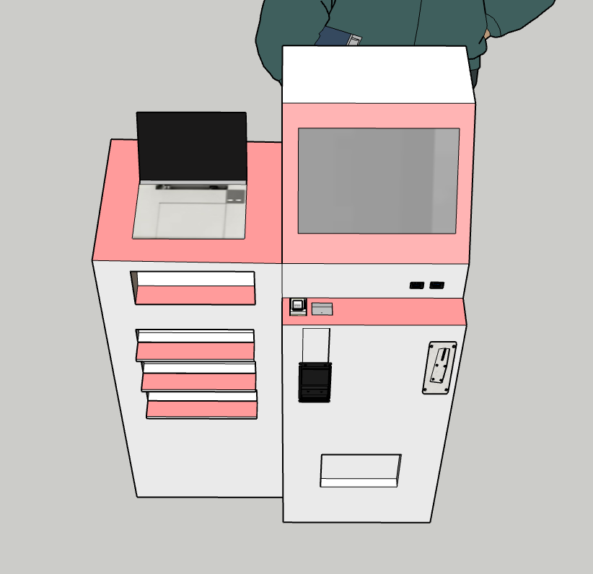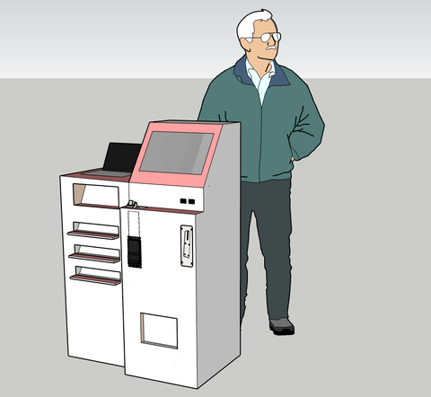

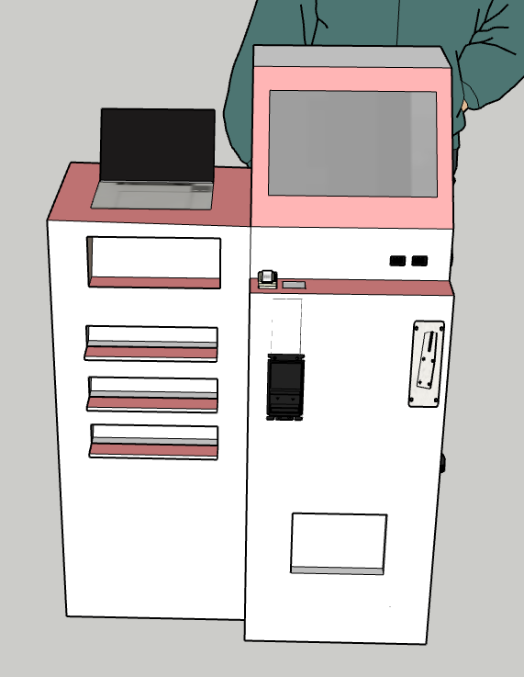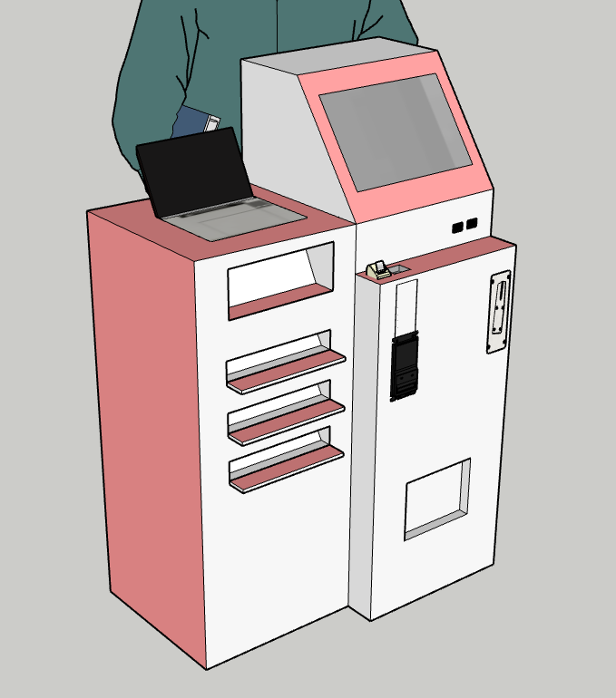

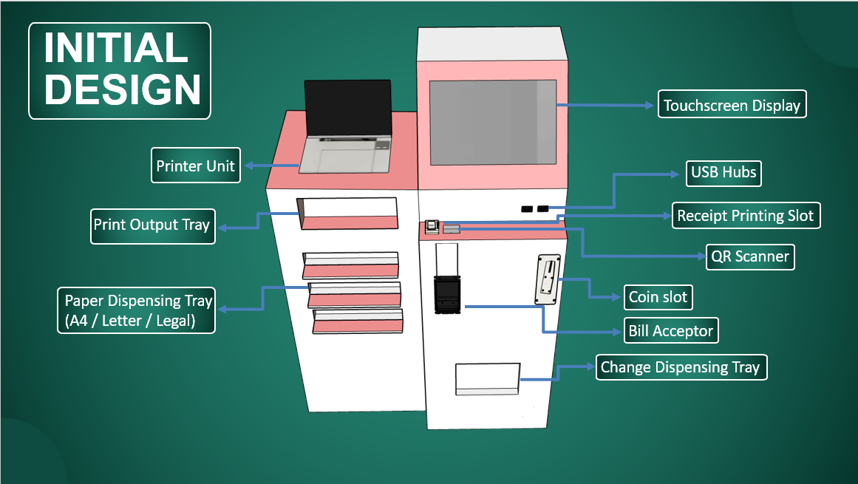















## Estimated Costs:

|  |  |  |  |
| --- | --- | --- | --- |
| **Qty.** | **Materials** | **Unit Price** | **Total Price** |
| 1 | Dell Optiplex 3000 (Intel N6005) | ₱4,980 | ₱4,980 |
| 1 | Arduino Nano | ₱132 | ₱132 |
| 1 | Canon Pixma G2010 | ₱6,795 | ₱6,795 |
| 1 | Allan Universal Coinslot | ₱404 | ₱404 |
| 1 | 10.1-inch Touchscreen LCD Display | ₱2,604 | ₱2,604 |
| 1 | Thermal Receipt Printer | ₱759 | ₱759 |
| 1 | Thermal Paper Rolls | ₱115 | ₱115 |
| 1 | Relay (2 way) | ₱53 | ₱53 |
| 1 | Bill Acceptor | ₱2,728 | ₱2,728 |
| 2 | Coin Hopper | ₱1,013 | ₱2,026 |
| 1 | QR Code Scanner | ₱519 | ₱519 |
| 1 | Bond Paper (Letter) | ₱189 | ₱189 |
| 1 | Bond Paper (A4) | ₱205 | ₱205 |
| 1 | Bond Paper (Long) | ₱245 | ₱245 |
| 1 | Awei CL-150T 4-Ports Hub | ₱193 | ₱193 |
| 1 | Power Supply | ₱175 | ₱175 |
| 1 | Power Adapter | ₱60 | ₱60 |
|  | Total: | ₱22,182 | |

## 

## Benefits of the Project:

The benefits of this project are:

* **For students and faculty members:** The project aims to provide a convenient, on-demand solution for document services within the campus. The kiosk is designed to support academic needs, including printing student assignments and preparing faculty materials. Furthermore, the introduction of a usage-based pricing model is intended to provide a fairer system, where the cost is based on the actual resources used. The integration of a touchscreen interface, QR code-based file uploading, and real-time pricing feedback enhances user interaction and encourages adoption by offering a modern, intuitive self-service experience aligned with students’ familiarity with digital technologies.
* **For Colegio de Montalban:** This research serves as an example of student-led innovation and the practical application of engineering concepts taught in the curriculum. The project presents a potential model for a modern campus amenity that supports academic services through automation and intelligent system design. The system is designed to allow future technological enhancements without major changes to its core functions, such as cashless payment integration, centralized system monitoring, and data-driven service optimization.
* **For the CDM Business Hub:** As the primary community partner, the Business Hub may benefit from operational insights generated by the kiosk, including system reliability and user reception of the dynamic pricing model. The data-driven and expandable design of the kiosk further provides a foundation for informed decision-making regarding future service improvements or technological upgrades.
* **To future researchers:** This study contributes a documented framework for integrating computer vision into a self-service kiosk to enable dynamic, usage-based pricing. The findings related to pricing accuracy, system reliability, and user trust may serve as a reference for future studies in automated retail systems, resource-based pricing models, and applied computer vision technologies.